- DEVELOP A LADDER LOGIC PROGRAM FOR SEQUENTIAL OPERATION OF STEPPER MOTOR
AIM:
To design a ladder logic program to perform the sequential operation of a stepper motor using PLC.

APPARATUS REQUIRED:
- Stepper motor
- PLC
- Versapro Software
- PC
- RS-232 Cable.
- Patch Chords

PROCEDURE:
- Load the Versapro Software to the PC.
- Open the Versapro Software.
- Switch ON the PLC Trainer and stepper motor .
- Connect PLC and stepper motor.
- Open the New folder and draw the ladder logic program.
- Connect the PLC to PC.
- Select the correct hardware Configuration [Sl. No].
- Store the Program to PLC.
- Run the Program.
- Verify the performance of the stepper motor.

WIRING DIAGRAM:
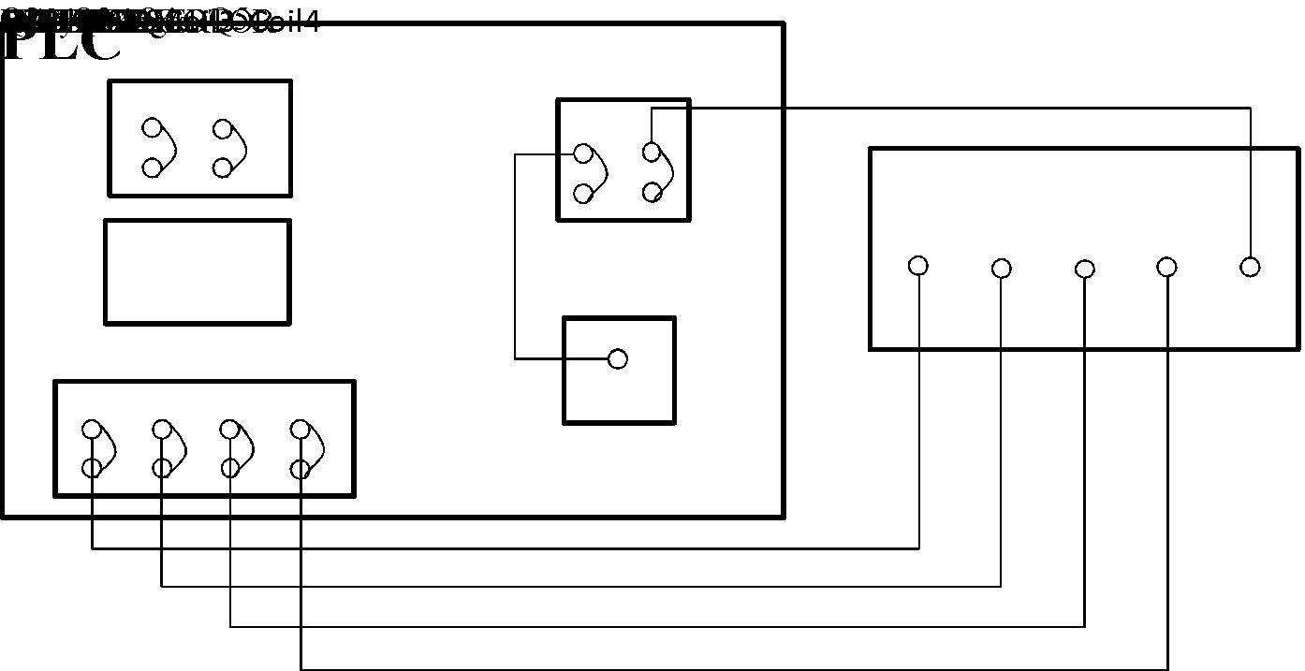

LADDERLOGICPROGRAM:
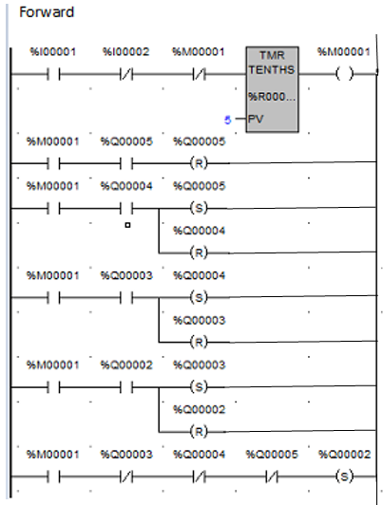

RESULT: Ladder logic program for sequential operation of stepper motor has been designed and the performance is tested using trainer kit.
- DEVELOP A LADDER LOGIC OF BOTTLE FILLING SYSTEM

AIM:
To design a ladder logic program to perform Bottle Filling System.

APPARATUS REQUIRED:
1. Bottle filling system.
2. PLC
3. Versapro Software
4. PC
5. RS-232 Cable.
6. Patch Chords

PROCEDURE:
1. Load the Versapro Software to the PC.
2. Open the Versapro Software.
3. Switch ON the PLC Trainer and Bottle filling system.
4. Connect PLC and Bottle Filling System kit.
5. Open the New folder and draw the ladder logic program.
6. Connect the PLC to PC.
7. Select the correct hardware Configuration [Sl. No].
8. Store the Program to PLC.
9. Run the Program.
10. Verify the performance of the Bottle Filling System.

PROGRAM FOR BOTTLE FILLING SYSTEM:

I1 = Input from proximity (Capacitive Pickup) sensor - Bottle indicator.
I2 = Input from position sensor.
I3 = Input from low level sensor in process tank.
I4 = Input from high level sensor in process tank.
Q1, Q2, Q3, Q4 = Output for stepper motor coil.
Q5 = Output for drives a pump.
Q6 = Output for drive a solenoid valve.

A motor (pump) is used to fill the process tank from reservoir. The motor is switched ON and OFF by two sensors which are placed in the process tank at two levels [LL & HL].
When the water level is below to the low level, both of the sensors output are low (I3 / I4) . So the motor is switched ON and water is poured into the process tank from reservoir. Even though the water level is increased above the low level sensor, the motor is at running condition, because of a feedback connected parallel to the low level sensor (I3). When the water level reaches the high level sensor (I4) the motor is turned Off as high level sensor broke the connection. When I1, I2 are high then M1 (Internal memory coil) energized which in turn energies solenoid valve Q6. The output for the Q6 is for specified timing, which is determined by on-delay timer PV (Preset Value). Next step is to rotate stepper motor by energizing four coils of it. The starting address of data are stored in sequence as explained below. SNX is to increment the starting register (SR) in array move function. The input to SNX is given through up counter register R1. The timing is decided with the help of on-delay timer present value.
First register data will be given in Q1 and incremented till Q4 which is clearly shown in the table. The rotation of the stepper motor stops when Q6 is low as I1 and I2 are high.
The operation continuous in these sequence.
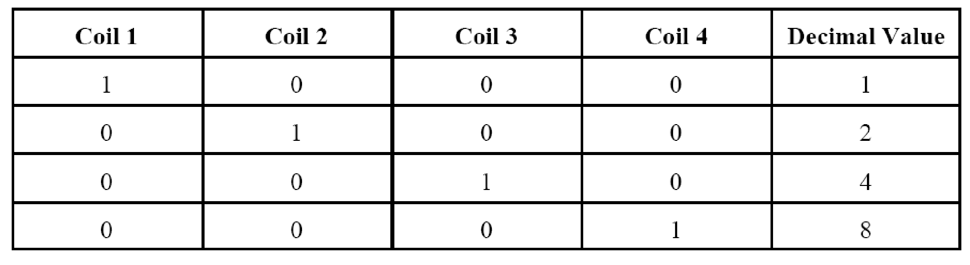

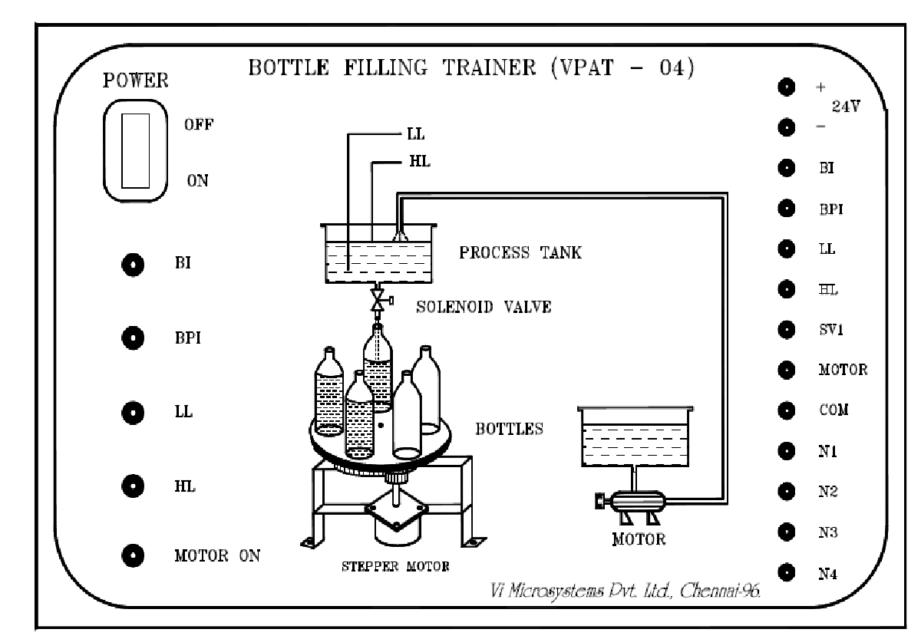

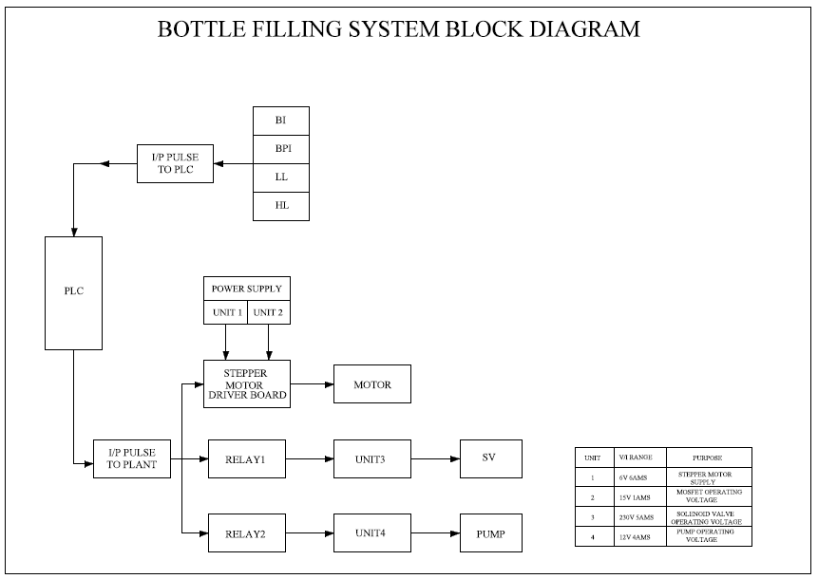

WIRING DIAGRAM:

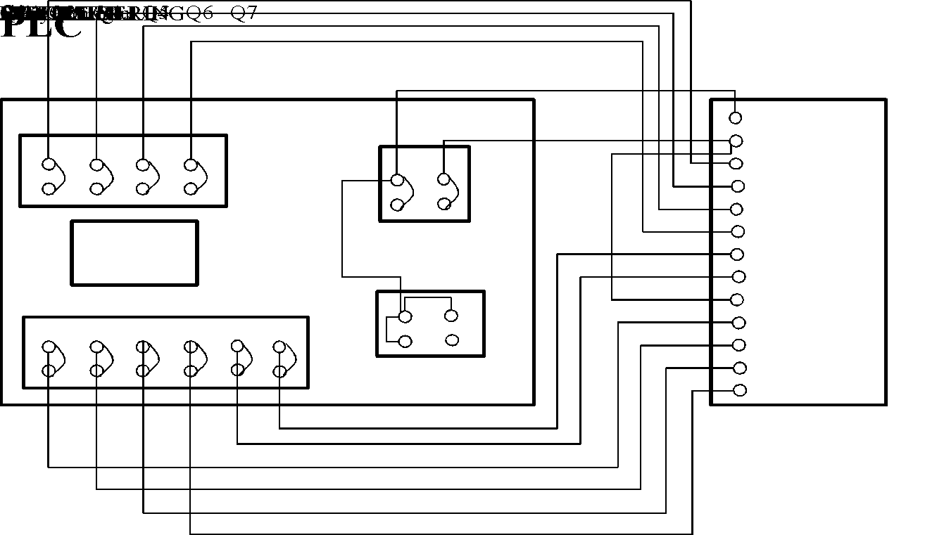

FLOWCHART:
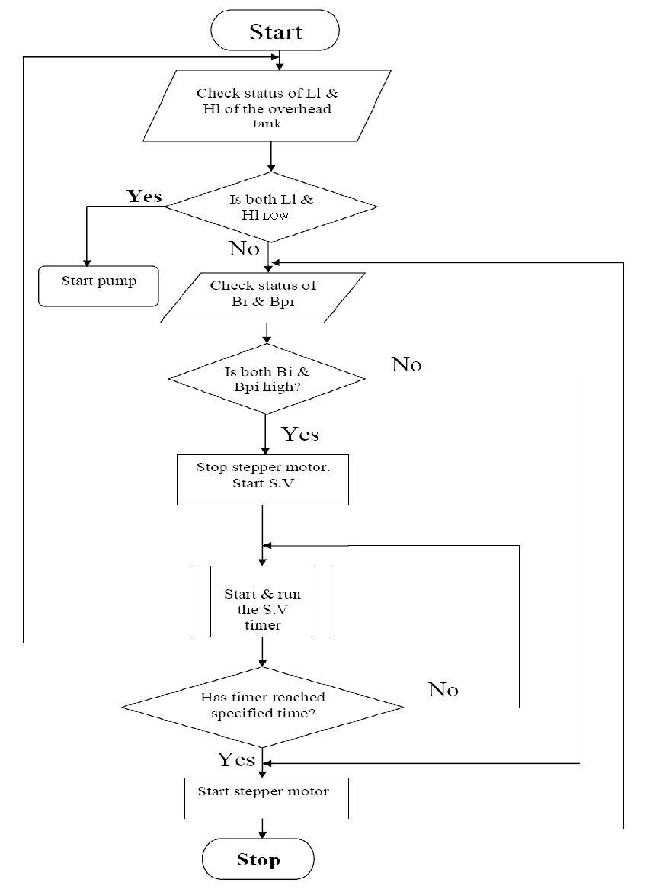

LADDER LOGIC PROGRAM:
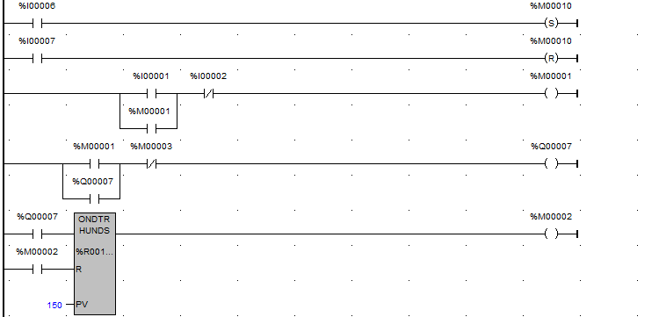
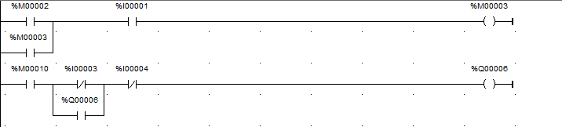
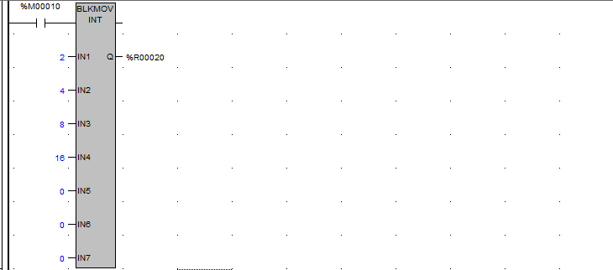
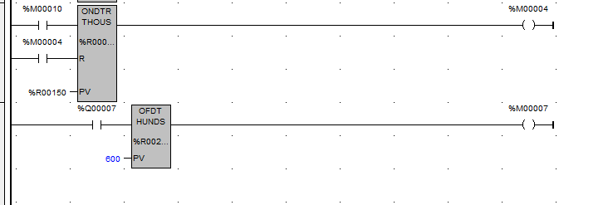

RESULT:
Ladder logic program for Bottle Filling System has been designed and the performance is tested using trainer kit.
- DEVELOP A LADDER LOGIC FOR TRAFFIC LIGHT CONTROL SYSTEM USING CODYSYS
Aim:
To implement a one way and two way traffic light control system for the given instruction using codysys and to show its visualisation.

ONE WAY DIRECTION:
Problem statement:
Red light glows for 30s, yellow light for 5 s, green light for 25s and this process continues. There is a start button and a stop button. Draw the ladder logic to implement the above process.
Flow diagram:
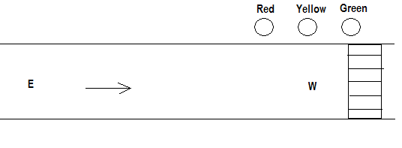
Ladder Logic:
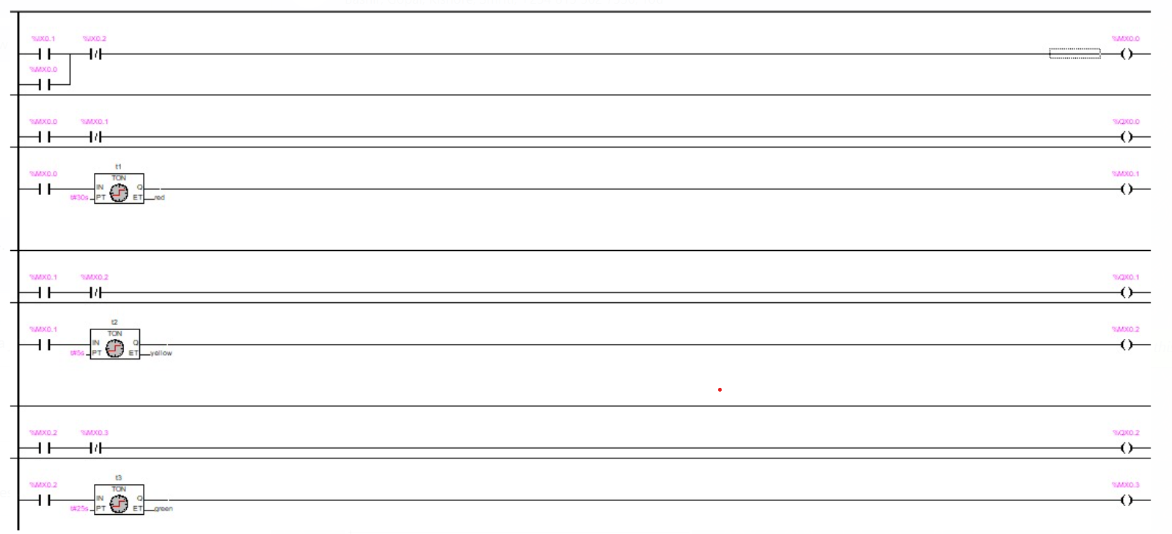
VISUALISATION:
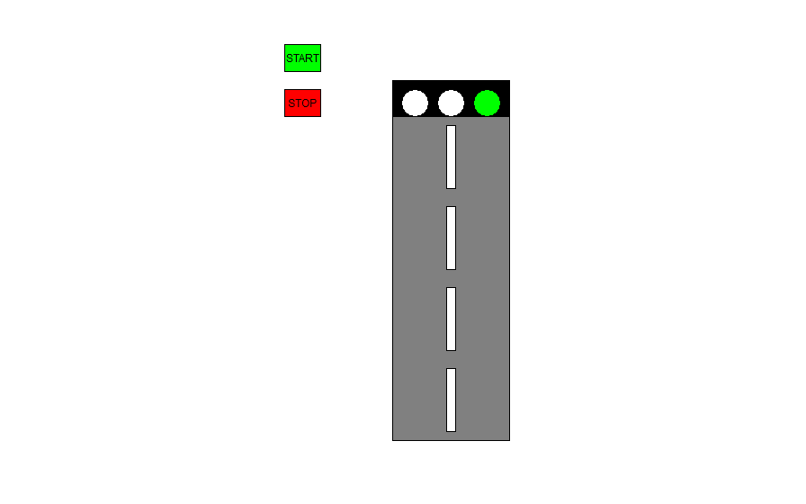
TWO WAY DIRECTION:
When Red 1 is ON for 30s, E-W traffic flows. At this instant, Yellow 2 becomes ON for 5s after which Green 2 becomes ON for 25s. After 30s, when Red 2 is ON for 30s, N-S traffic flows. At this instant, Yellow 1 becomes ON for 5s after which Green 1 becomes ON for 25s and this process continues. There is a start button and a stop button. Draw the ladder logic to implement the above process.
Flow diagram:
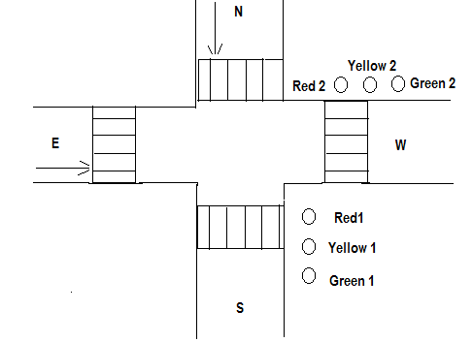

Ladder Logic:
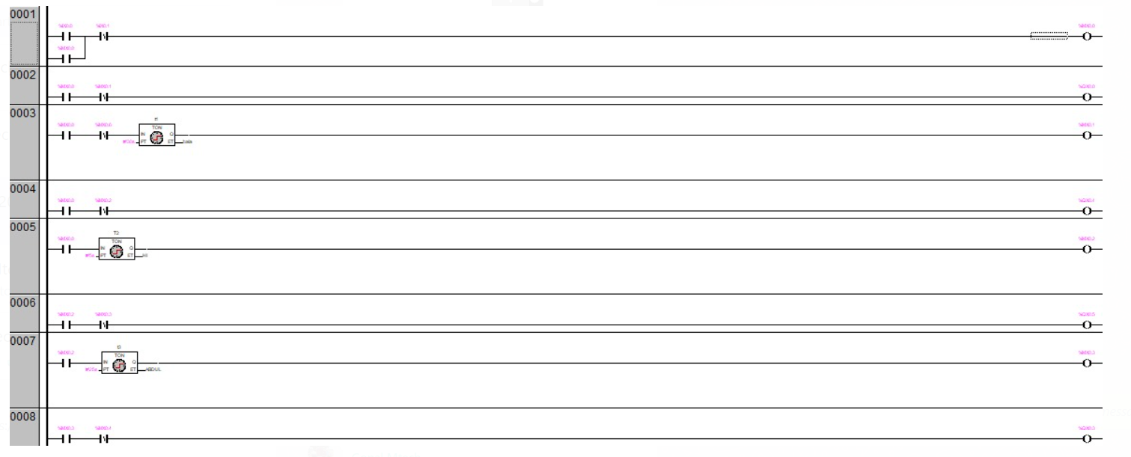
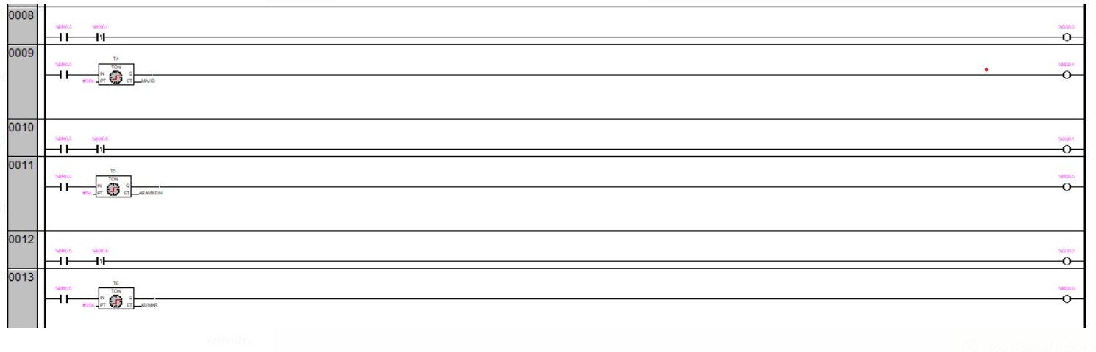VISUALISATION: 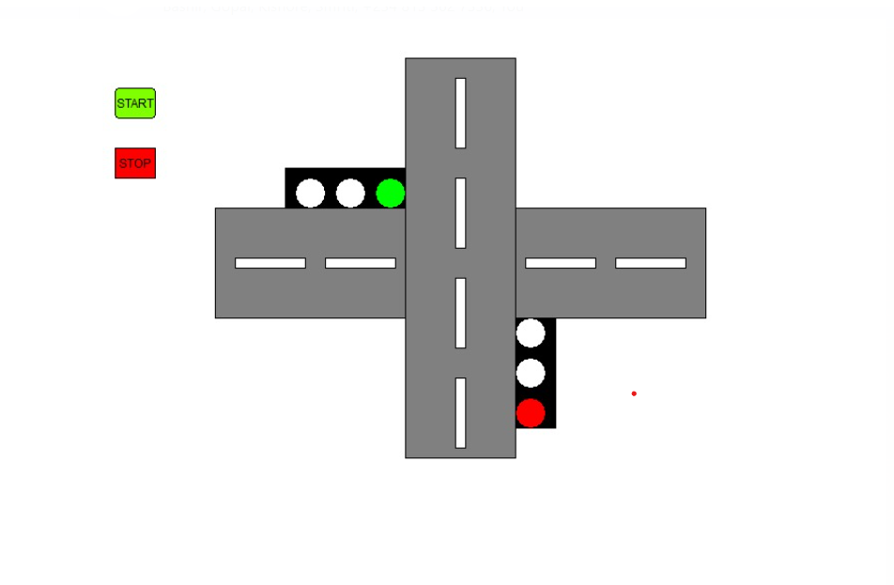
Result:
Thus the one way and two way traffic light control was executed and verified using codysys software.
8. DEVELOP A LADDER LOGIC FOR TRAFFIC LIGHT CONTROL SYSTEM USING PLC AND HMI
Aim:
To implement a one way and two way traffic light control system for the given instruction in mitshubishi PLC and HMI.
APPARATUS REQUIRED:

1. Mitsubishi FX5U [PLC Trainer kit].
2. PC.
3. Ethernet cable.

PROCEDURE:
- Load the GX Works 3 Software to the PC.
- Open the GX Works 3 Software.
- Switch ON the PLC Trainer .
- Open the New folder and draw the ladder logic program.
- Connect the PLC to PC.
- Select the correct hardware Configuration [Sl. No].
- Store the Program to PLC.
- Run the Program.
- Verify the performance of the one way and two way traffic control system in Mitsubishi kit.

ONE WAY DIRECTION:
Problem statement:
Red light glows for 30s, yellow light for 5 s, green light for 25s and this process continues. There is a start button and a stop button. Draw the ladder logic to implement the above process.

Flow diagram:


Ladder Logic:
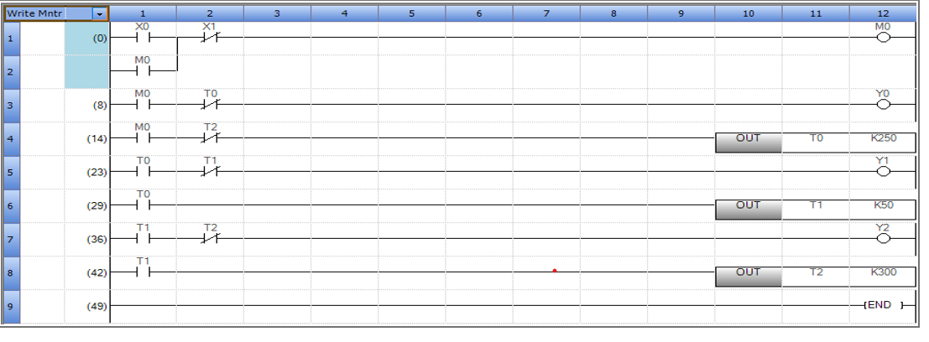
visualisation:
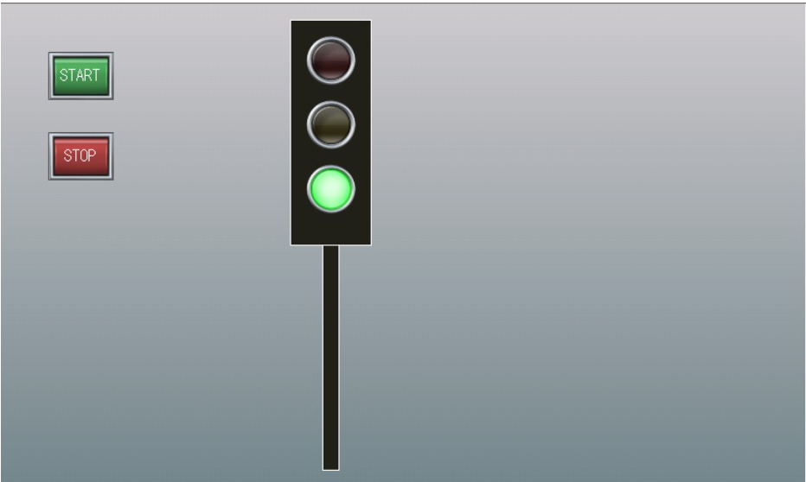

TWO WAY DIRECTION:
When Red 1 is ON for 30s, E-W traffic flows. At this instant, Yellow 2 becomes ON for 5s after which Green 2 becomes ON for 25s. After 30s, when Red 2 is ON for 30s, N-S traffic flows. At this instant, Yellow 1 becomes ON for 5s after which Green 1 becomes ON for 25s and this process continues. There is a start button and a stop button. Draw the ladder logic to implement the above process.

Flow diagram:

Ladder Logic:
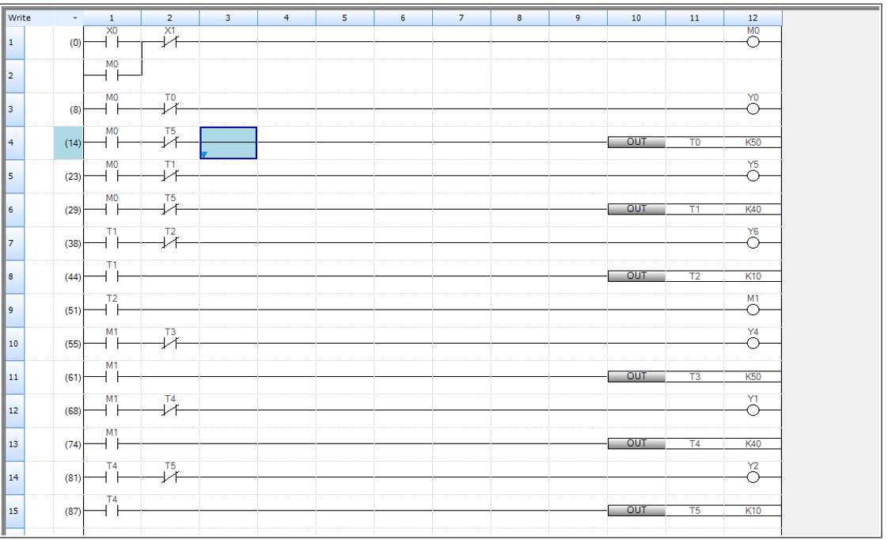

VISUALISATION:
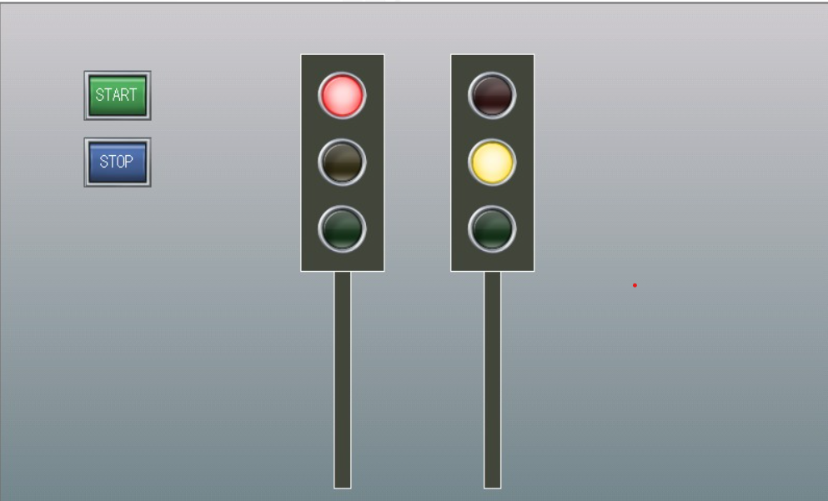

Result:Thus the one way and two way traffic light control was executed and verified using PLC AND HMI.

9. DC MOTOR SPEED CONTROL SYSTEM

AIM
To control the speed of the PMDC motor using PLC

APPARATUS REQUIRED
1. Speed Control Module Trainer (VSAT-01).
2. Versamax Micro PLC.
3. PC
4. RS-232Cable
5. 12V DC Motor
6. Patch Chords.

PROCEDURE
1. Write your application program in the programming area.
2. Store the program to PLC.
3. After storing to set the P,I,D values in the PID function tuning Parameters task.
4.Right click over the PID function click the Tuning Parameters task.
5. Now the PID tuning Parameter control dialogue box appear in the screen.
Here to set the following values in the particular parameters
P = 1
I = 0.1
D = 0.1 to 7 (Respective your application output oscillation to change the D value)
Sample Period = 0.01 Sec
Upper clamp = 32000
SP/PV Range = 32000 M
6. Using patch cards, connect the PLC PWM output to the input of Analog output point in the
speed control module trainer kit.
7. Using Patch cards connect the speed control module trainer kit analog input to PLC HSC
input.
8. Run the program
9. Set motor speed in PC through a Versapro Software.

PID IND BLOCK
The independent algorithm (PID IND) is the close loop control algorithm. The PID function has six input parameter: a process set point (SP), a process variable (PV) , a manual / auto Boolean switch (MAN), a manual mode up adjustment input (UP), and manual mode down adjustment (DN). It also has an address, which specifies the location of a block of parameters associated with the function. It has two output parameters, a successful Boolean output and the control variable result (CV). If the manual input is true, the PID block is placed in manual mode and the output control variable is set from the Manual command parameter %Ref + 13. If either the UP or DN inputs are true, the manual command word is incremented or decremented by one CV count every PID solution. For faster manual changes of the output control variable, it is also possible to add or subtract any CV count value directly fo / from the manual command word.

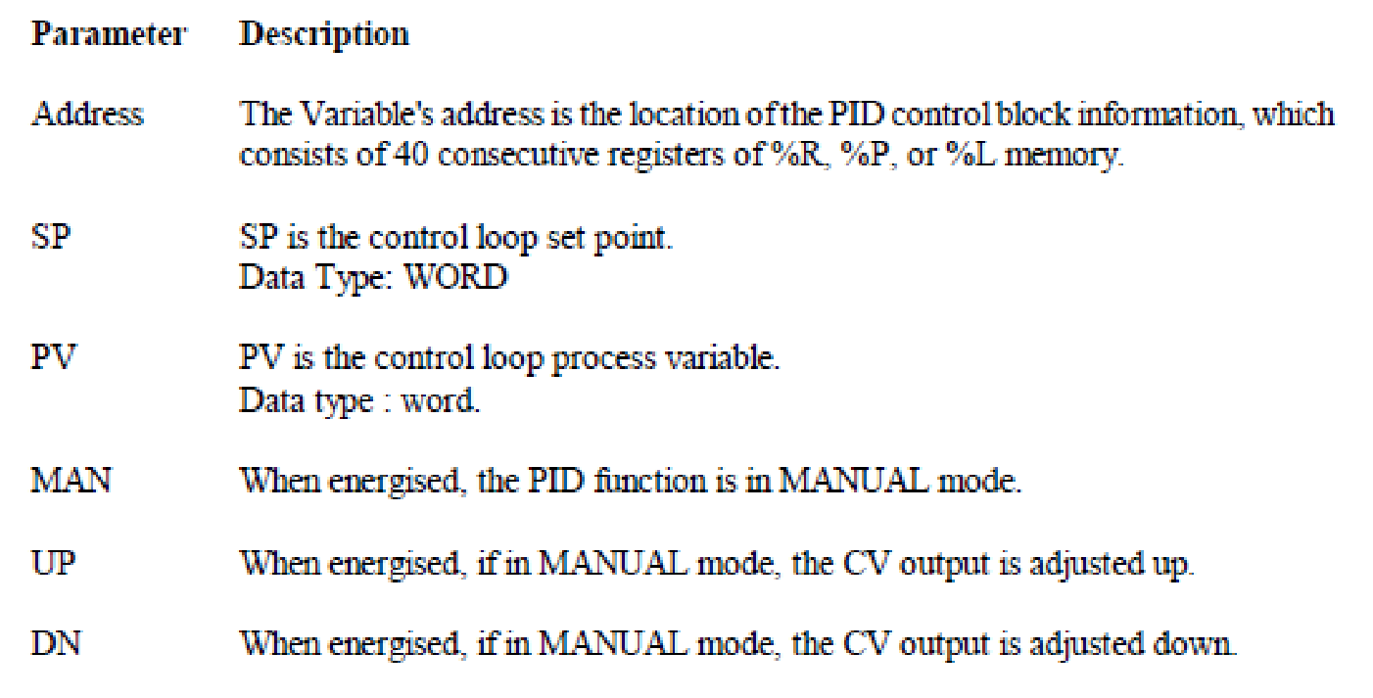
SCALE INT
Use this function to scale an input value and place it in an accumulator. This function has five
inputs/parameters. For the integer based version of the function (SCALE-INT) all the parameters
be integer based (signed).

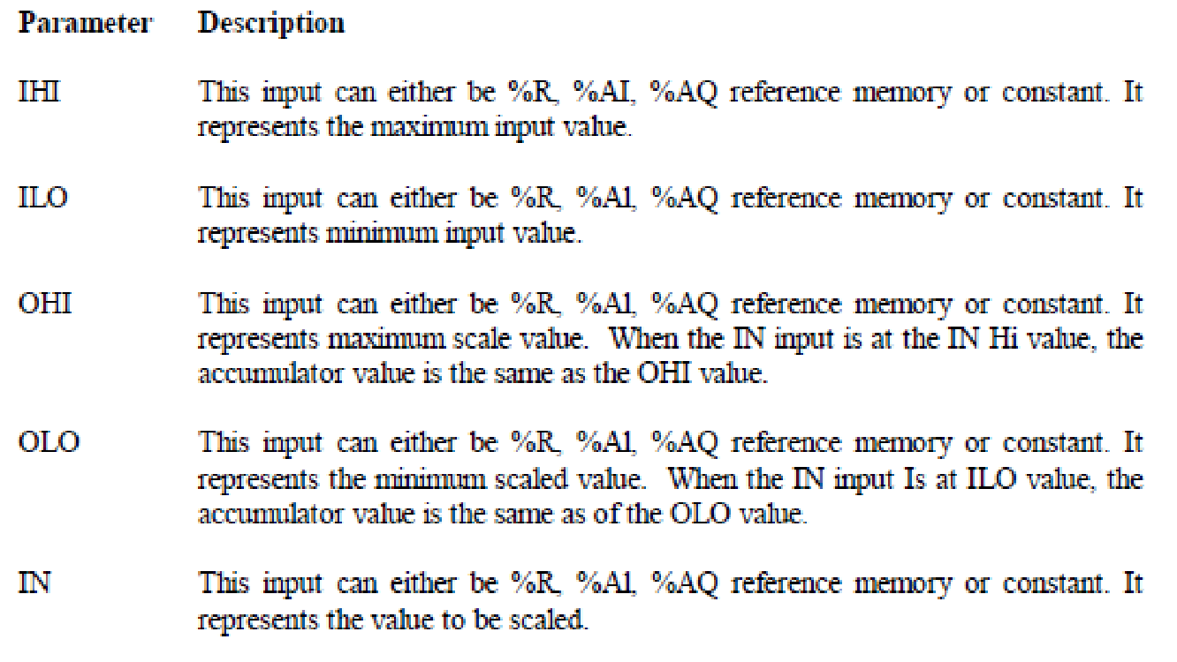
Analog Input to PLC Process Variable (PV) from the 'motor.
Analog output from PLC Control variable (CV) to the motor.
The set point is given to PLC.
The- process variable (PV) from the motor is given as input to the Analog input of PLC. The PLC performs, the control operation and gives the control variable (CV) to control PMDC motor.
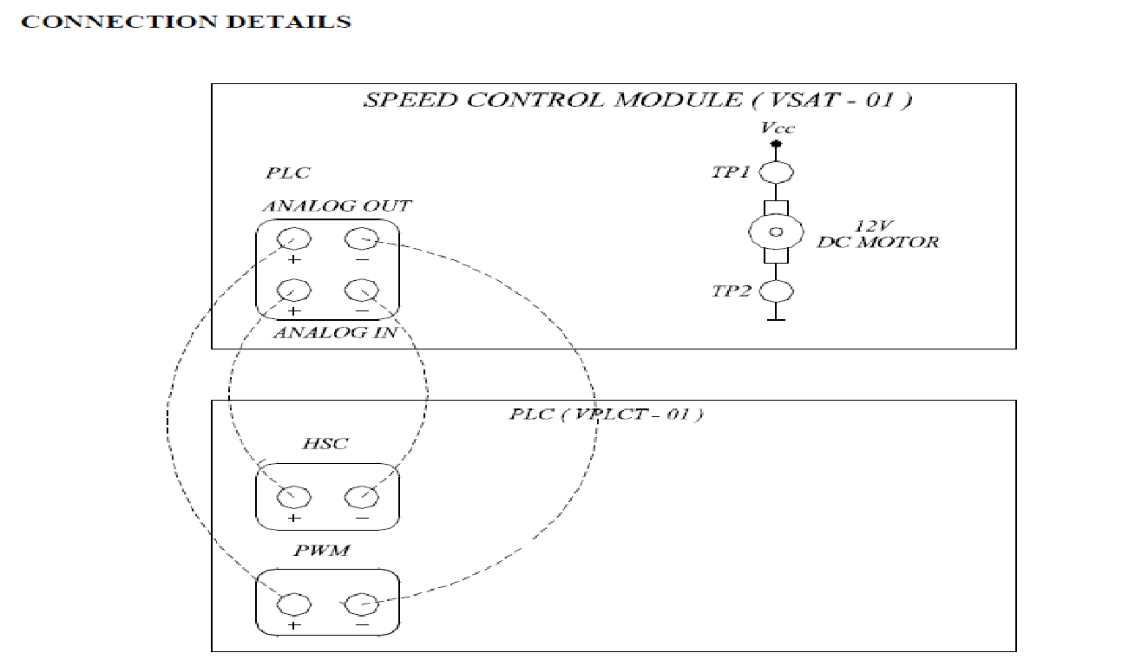

Ladder Diagram: 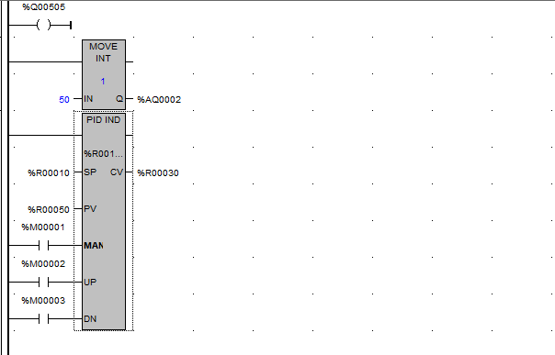

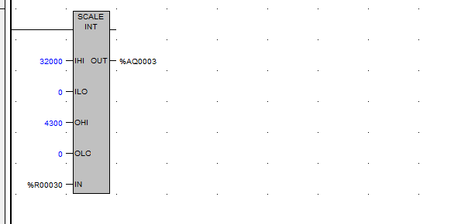
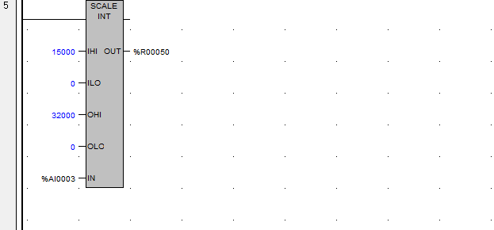

Result: Thus the speed of the PMDC motor is controlled and verified using PLC.
10(a). SINGLE ACTING PNEUMATIC CYLINDER OPERATION

AIM:To develop ladder logic for single acting pneumatic cylinder operation using PLC.
APPARATUS REQUIRED:

1. SIEMENS PLC Trainer kit.
2. PC.
3. Ethernet cable.

PROCEDURE:
- Load the Software to the PC.
- Open the Software.
- Switch ON the PLC Trainer .
- Open the New folder and draw the ladder logic program.
- Connect the PLC to PC.
- Select the correct hardware Configuration [Sl. No].
- Store the Program to PLC.
- Run the Program.
- Verify the performance of single acting pneumatic cylinder operation.
PROBLEM DESCRIPTION: The operation of single Acting pneumatic cylinder by using two push buttons PB1 and PB2.PB1 is for start the operation and is for stop the operation.

DIAGRAM:
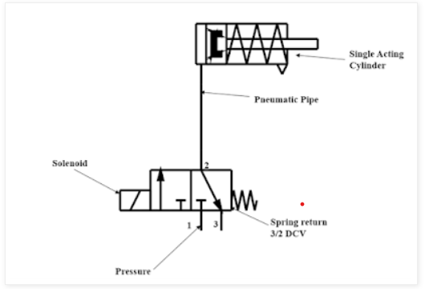
LADDER DIAGRAM: 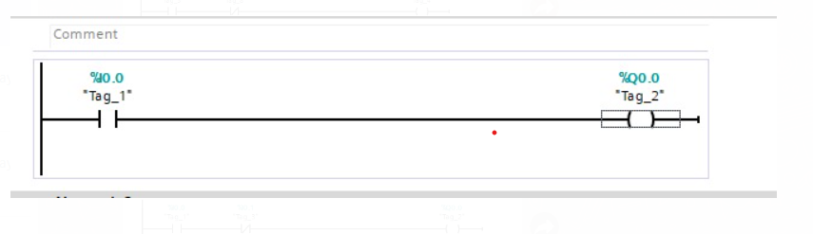

RESULT:
Thus the single acting pneumatic cylinder operation is carried out and verified using SIEMENS PLC.

10(b). DOUBLE ACTING PNEUMATIC CYLINDER OPERATION

AIM:To develop ladder logic for double acting pneumatic cylinder operation using PLC.
APPARATUS REQUIRED:

1. SIEMENS PLC Trainer kit.
2. PC.
3. Ethernet cable.

PROCEDURE:
- Load the Software to the PC.
- Open the Software.
- Switch ON the PLC Trainer .
- Open the New folder and draw the ladder logic program.
- Connect the PLC to PC.
- Select the correct hardware Configuration [Sl. No].
- Store the Program to PLC.
- Run the Program.
- Verify the performance of single acting pneumatic cylinder operation.
PROBLEM DESCRIPTION: The operation of double Acting pneumatic cylinder by using two push buttons PB1 and PB2.PB1 is for start the operation and is for stop the operation.

DIAGRAM:

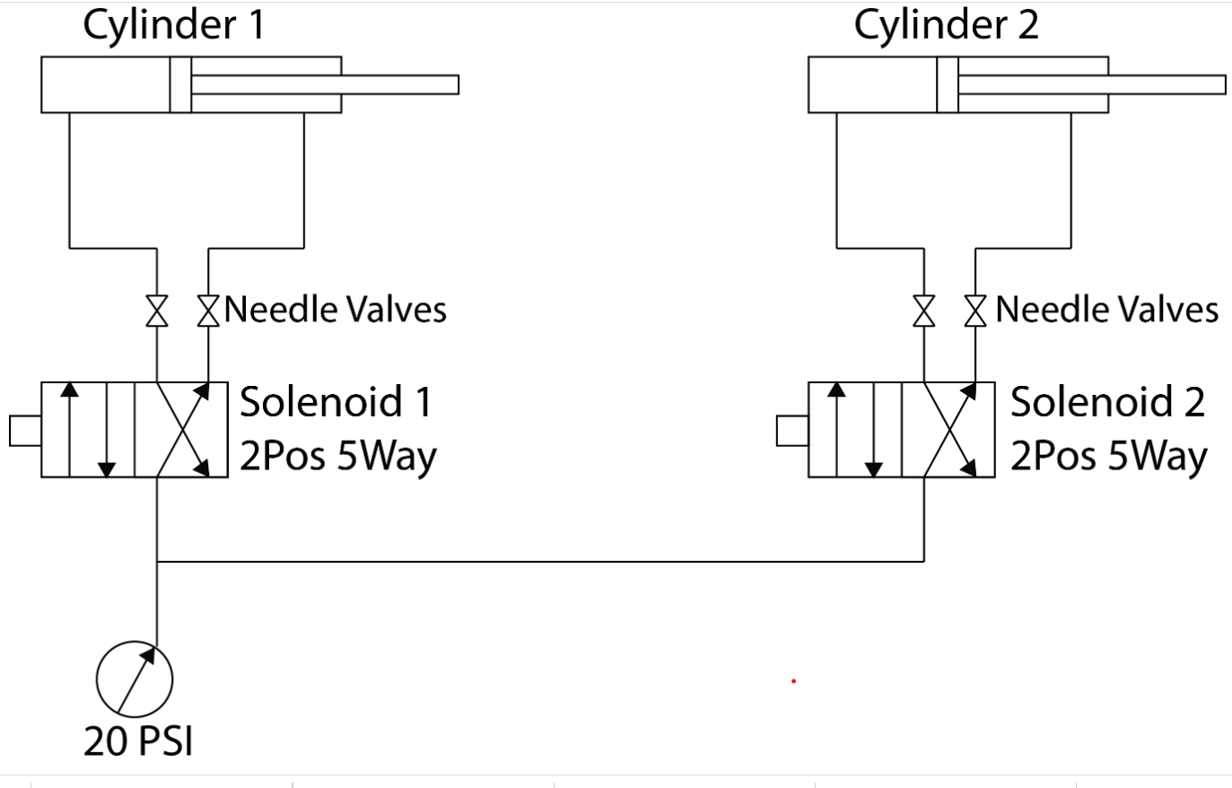

LADDERDIAGRAM: 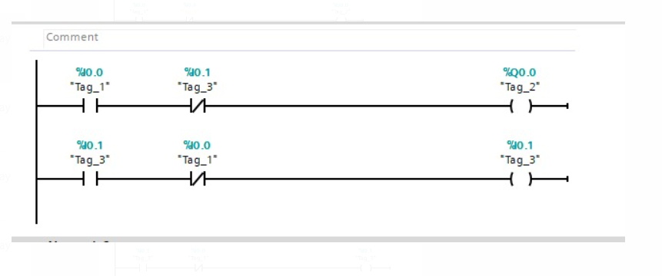

RESULT:
Thus the double acting pneumatic cylinder operation is carried out and verified using SIEMENS PLC.

ASSIGNMENT
1. CONTROL OF DOUBLE ACTING CYLINDER OPERATION
AIM:To develop ladder logic for control of double acting pneumatic cylinder operation using PLC.
APPARATUS REQUIRED:

1. SIEMENS PLC Trainer kit.
2. PC.
3. Ethernet cable.

PROCEDURE:
- Load the Software to the PC.
- Open the Software.
- Switch ON the PLC Trainer .
- Open the New folder and draw the ladder logic program.
- Connect the PLC to PC.
- Select the correct hardware Configuration [Sl. No].
- Store the Program to PLC.
- Run the Program.
- Verify the performance of single acting pneumatic cylinder operation.
PROBLEM DESCRIPTION: The operation of double Acting pneumatic cylinder by using two push buttons PB1 and PB2.PB1 is for start the operation and is PB2 for stop the operation.when the cylinder 1 is extended and the cylinder 2 should be retracted and vice versa.

DIAGRAM:



LADDER DIAGRAM:
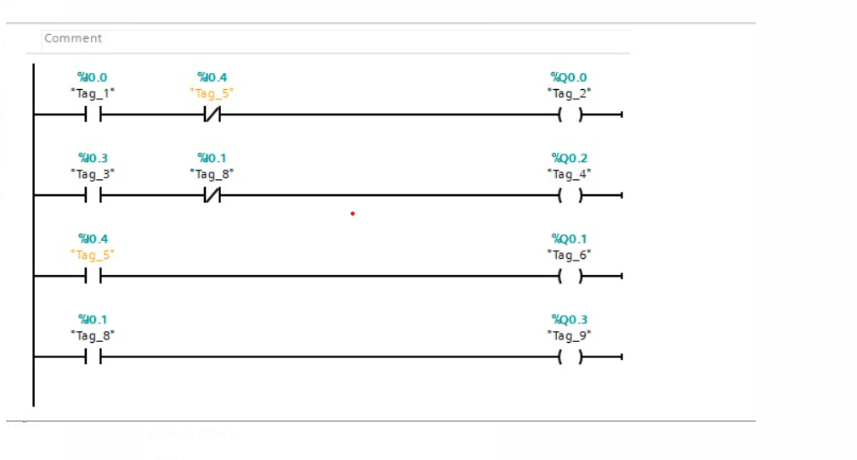
RESULT:
Thus the control of double acting pneumatic cylinder operation is carried out and verified using SIEMENS PLC.

